**Post-Impressionism**

The British critic Roger Fry devised the term Post-Impressionism in 1910 while organising an exhibition in London at the Grafton Galleries to introduce recent French art to the British public. For him, Post-Impressionism meant painters who “consider the Impressionists too naturalistic.” He argued that Post-Impressionist painters privileged the simplicity of form and the expression of emotions over the Impressionists’ tendency to capture mere “shimmer and colour.” Fry singled out Paul Gauguin, Vincent van Gogh and Paul Cézanne for their efforts to advance Impressionism. An exhibition at the Museum of Modern Art in New York in 1929, organized by Alfred H. Barr, Jr. added Georges Seurat to the core group of Post-Impressionists. Barr declared that through their artistic innovations, all four artists had emerged from “the Impressionist blind-alley.” While subsequent exhibitions and publications have attempted to broaden the range of artists who could be considered Post-Impressionists (for example, an exhibition organised by the Royal Academy of Arts in London in 1979), Seurat, Gauguin, van Gogh, and Cézanne continue to be celebrated as the artists who made the most noteworthy contributions to Post-Impressionism, forging the way to Fauvism, Cubism, Expressionism, and beyond.

The emergence of Post-Impressionism is closely aligned with the demise of Impressionism. In 1886, Impressionist artists organised their eighth – and what was to become their final – exhibition. Twelve years after their first exhibition in 1874, the Impressionists found themselves splintering apart, as they, their critics, and other artists began to look for new means of artistic expression that depended less on optical effects and more on underlying structure and form. For one younger artist, Georges Seurat, the solution was to instill Impressionist subject matter – scenes of everyday life – with a sense of permanence, derived from classical precedents. Seurat developed a new method of applying paint based on colour theory. Forsaking the loose brushstrokes of the Impressionists, he replaced them with small dots in complementary colours, applied tightly and systematically. Seurat introduced his new method, which he called Chromo-luminarism, at the 1886 Impressionist exhibition, alongside work in the same manner by fellow artists Paul Signac and Camille Pissarro. The critic Félix Fénéon dubbed the new technique Neo-Impressionism, while Signac favoured Divisionism. Other critics, however, coined the term Pointillism, and it is by this name that the method is usually known.

Paul Gauguin, who began exhibiting with the Impressionists in 1879, also sought ways to rejuvenate painting during the 1880s. He initially found direction through the work of a younger artist, Émile Bernard, whom he met in Brittany. Gauguin emulated Bernard’s style of painting, which involved applying patches of bright, flat, non-naturalistic colour onto the canvas, surrounded by dark contours. Known as Cloisonnism, the style’s name came from its resemblance to cloisonné enamel work. The appeal of Cloisonnisim to Gauguin was its rejection of the illusion of three-dimensionality, and its expressive potential. To set his work apart from Bernard’s, Gauguin deemed his new mode of working Synthetism, by which he meant painting that did not simply privilege subject matter but also emphasized form and feeling. His years spent in Tahiti inspired work incorporating subjects and motifs from the more “primitive” world that Gauguin sought out as he rejected European materialism. His increasing insistence on depicting scenes sparked by ideas, emotions, and visions linked him to the writers and painters of the European Symbolist movement.

The Dutch painter Vincent van Gogh arrived in Paris in 1886. Prior to his move to Paris, van Gogh produced paintings in a dark palette that depicted scenes of rural life. Once in Paris, his paintings lightened considerably, and for a short period he experimented with the Pointillist method. Like other artists he met, he also found inspiration in Japanese prints. In 1888, tired of Paris, van Gogh moved to Arles, in the south of France, where his palette intensified under the bright Provençal sun. Gauguin joined him there for a short time. Like Gauguin, van Gogh favoured arbitrary, non-naturalistic colours, although he differed in that his work continued to spring from scenes he saw before him, rather than from his imagination. Nonetheless, van Gogh’s paintings took on an otherworldly quality, permeated with emotional, expressive energy that made inanimate objects and scenery seem almost alive. Van Gogh’s insistence on the symbolic value of colour, and his use of colour to express his emotions, held particular appeal for Symbolist writers and artists.

Paul Cézanne was affiliated with the Impressionists from as early as 1874, when he exhibited his paintings in the first Impressionist exhibition. However, his work was not well received and he began to spend increasing time in his birthplace, Aix-en-Provence, in the south of France. There he attempted to correct what he found lacking in Impressionism. Focussing on still life paintings and landscapes, Cézanne developed a new approach to painting that stood in opposition to the prevailing Impressionist style: rather than trying to capture his optical impressions on the canvas, he aimed to depict the underlying solidity of the objects or scenes before him, by methodically building up form through colour. Most provocatively, Cézanne deliberately broke the rules of perspective; instead, he tried to mimic on canvas the actual movements of the human eye, by portraying surfaces from a number of different viewpoints.

None of these artists gained widespread recognition in their lifetimes. However, by challenging the central tenets of Impressionism, each contributed in his own way to the emergence of modern art in the early twentieth century. Alfred H. Barr, Jr. summed up their contributions through a chart he developed in 1936, where he plotted out the means by which their bold experiments paved the way to Fauvism, Cubism, Expressionism, and, ultimately, to Abstract Art.

**References and further reading**

*Manet and the Post-Impressionists*, exhibition catalogue, 8 November 1910 – 15 January 1911, Grafton Galleries, London

https://archive.org/details/manetpostimpress00graf

*The Museum of Modern Art First Loan Exhibition New York November 1929: Cézanne, Gauguin, Seurat, Van Gogh*, exhibition catalogue, November 1929, The Museum of Modern Art, New York

*Post-Impressionism: Cross Currents in European Painting*, exhibition catalogue, 17 November 1979 – 16 March 1980

Rewald, J. (1979, 3rd edition) *Post-Impressionism from Van Gogh to Gauguin*, New York: Museum of Modern Art.

Thomson, B. (1998) *Post-Impressionism*, London: Tate Gallery Publishing.

Thomson, B. (1983) *The Post-Impressionists*, Oxford: Phaidon Press.

**Images**

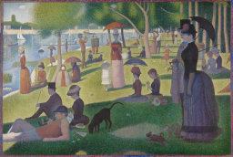

Georges Seurat, A Sunday on La Grande Jatte -- 1884, 1884–86, oil on canvas,  
207.5 x 308.1 cms

<http://www.artic.edu/aic/collections/artwork/27992?search_no=4&index=2>

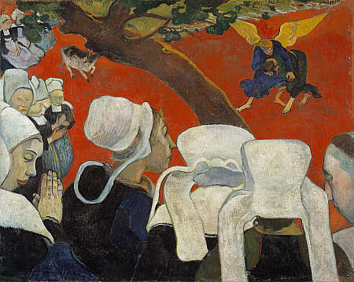

Paul Gauguin, Vision of the Sermon (Jacob Wrestling with the Angel), 1888, oil on canvas, 72.20 x 91.00 cms

http://www.nationalgalleries.org/collection/artists-a-z/G/3374/artist_name/Paul%20Gauguin/record_id/2438

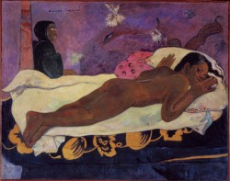

Paul Gauguin, Spirit of the Dead Watching, 1892, oil on burlap mounted on canvas, 116.05 x 134.62 x 13.34 cms

<http://www.albrightknox.org/collection/search/piece:511/>

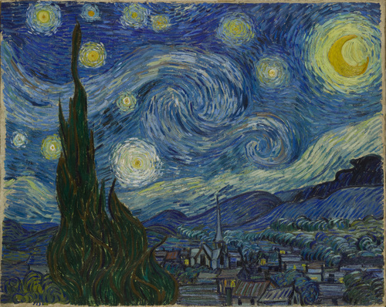

Vincent van Gogh, The Starry Night, 1889, oil on canvas, 73.7 x 92.1 cms

<http://www.moma.org/collection/browse_results.php?criteria=O%3AAD%3AE%3A2206|A%3AAR%3AE%3A1&page_number=3&template_id=1&sort_order=1>

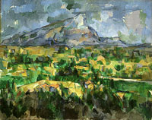

Paul Cézanne*,* Mont Sainte-Victoire*,* 1902-4, oil on canvas, 73 x 91.9 cms <http://www.philamuseum.org/exhibitions/312.html?page=3>

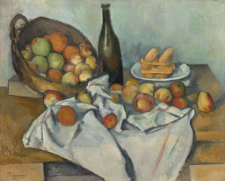

Paul Cézanne The Basket of Apples, c. 1893, oil on canvas, 65 x 80 cms

<http://www.artic.edu/aic/collections/artwork/111436?search_no=9&index=1>

he chart in our show is not the first to map the history of modern art. The Museum&#8217;s first director, Alfred Barr, made a famous one for his landmark exhibition Cubism and Abstract Art, in 1936. Our typography and font were chosen in homage to his. Barr&#8217;s handwritten versions of the chart are preserved in MoMA&#8217;s Archives.
Here is one example of Barr&#8217;s handwritten chart in MoMA&#8217;s Archives 

Alfred H. Barr, Jr. , Chart of Modernist Art History, jacket for the exhibition catalogue Cubism and Abstract Art. New York: The Museum of Modern Art, 1936

http://inventingabstraction.tumblr.com/post/41701591608/the-chart-in-our-show-is-not-the-first-to-map-the